# Supplementary Material

## Tables and Figures

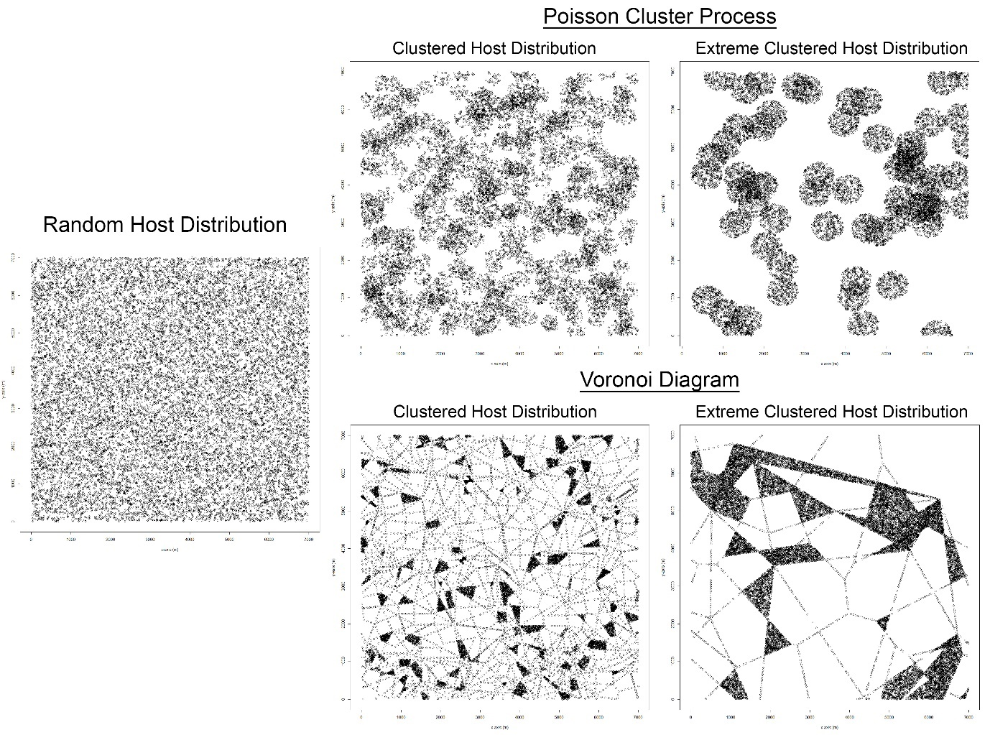

Figure S2: Examples of all the different host landscape types. Each plot has the same number of points (15,941).

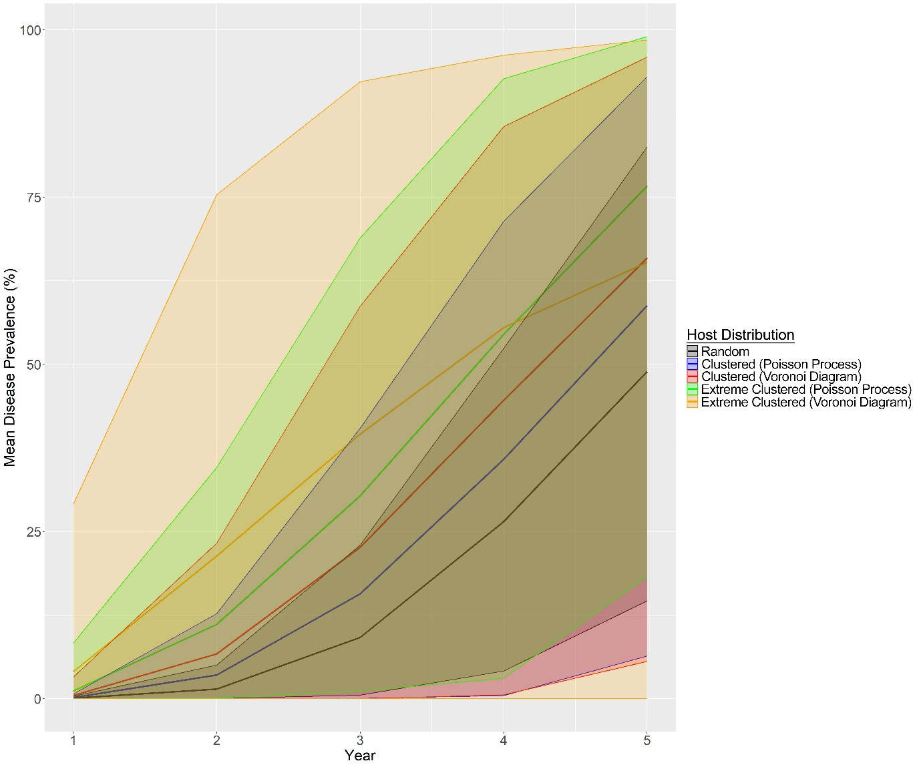

Figure S2: The change in mean disease prevalence of the host landscape types generated with the three different host distribution methods and with different levels of clustering. The envelopes represent the 95% quartile range which are estimated from 500 realizations for each year.

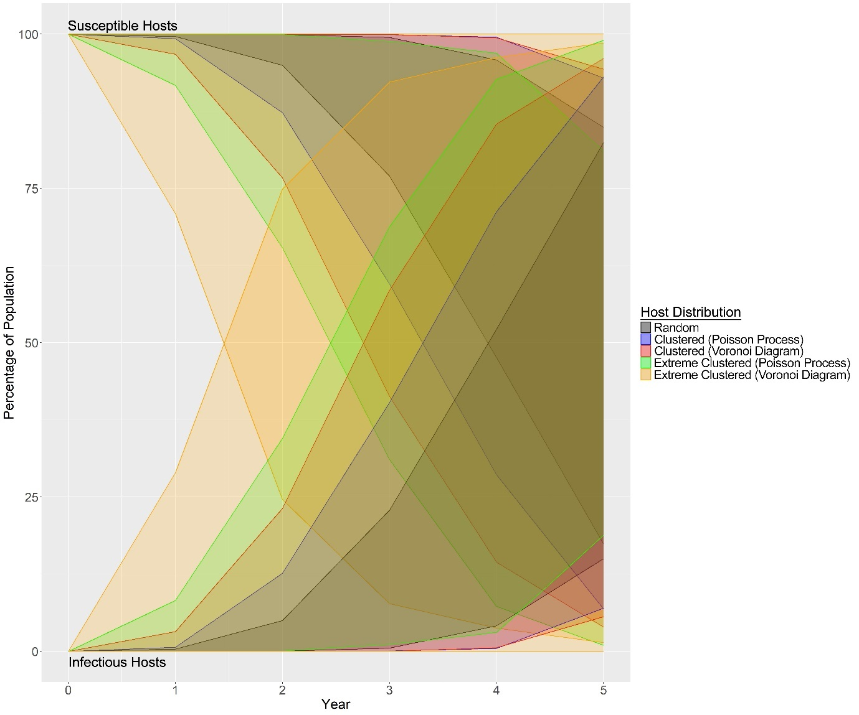

Figure S3: Graph showing the change in the percentage of susceptible and infectious hosts in the population for each of the host landscape types. Envelopes represent the 95% quartile range which are estimated from 500 realizations for each year.

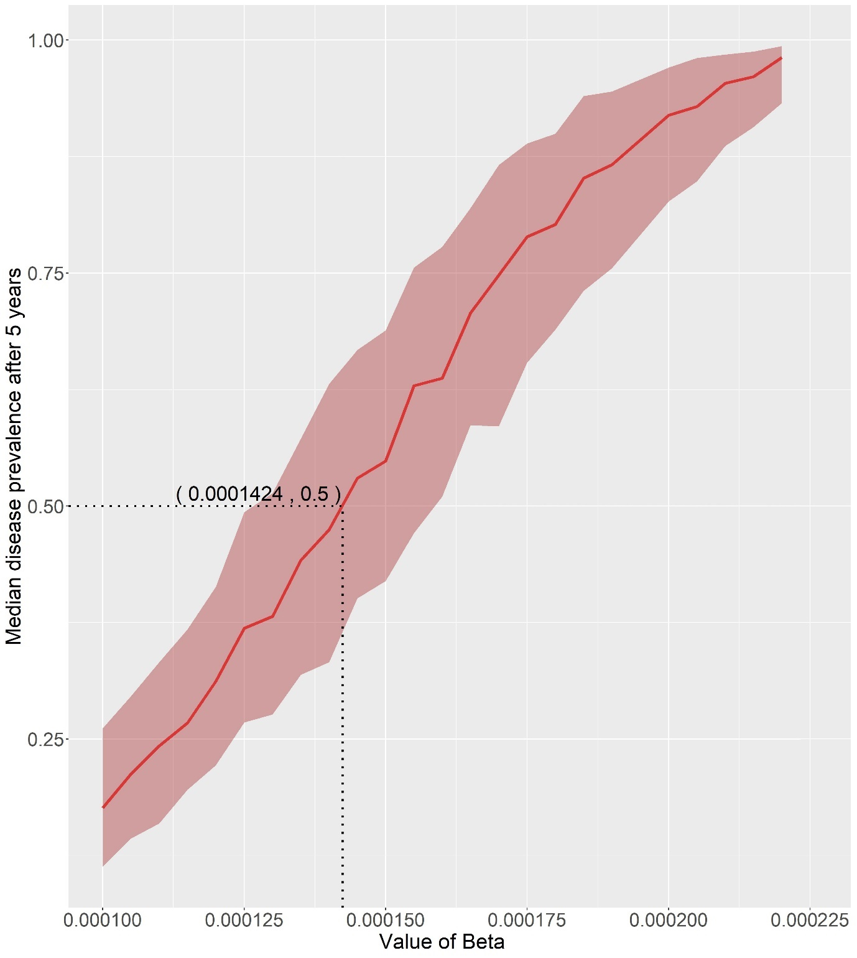

Figure S4: Graph showing the results of the line method used to parameterize the baseline infection rate ($β$) to achieve a median prevalence level of 50% after 5 years. Error envelope represents the interquartile range.

Table S1: Summary of how each strategy calculates the length of the radius. Where $n$ is the number of years, $g$ is the number of generations, $D$ is the estimated maximum yearly spread distance of the pest, and $δ$ is the estimated maximum spread distance of each generation.

|  |  |
| --- | --- |
| **Strategy** | **How Radius Length is Calculated** |
| In-to-Out (Gamma Year) | $${Radius}_{i}=gamma\left(n_{i}, -\frac{ln⁡(1-0.95)}{D}\right)$$ |
| In-to-Out (Gamma Gen) | $${Radius}_{i}=gamma\left(g_{i}, -\frac{ln⁡(1-0.95)}{δ}\right)$$ |
| In-to-Out (Linear) | $${Radius}_{i}=n_{i}×D$$ |
| Adaptive (Gamma Year) | $${Radius}_{i}=gamma\left(n_{i}, -\frac{ln⁡(1-0.95)}{D}\right)$$ |
| Adaptive (Gamma Gen) | $${Radius}_{i}=gamma\left(g_{i}, -\frac{ln⁡(1-0.95)}{δ}\right)$$ |
| Adaptive (Linear) | $${Radius}_{i}=n_{i}×D$$ |
| Multi-foci | $$Radius=D$$ |

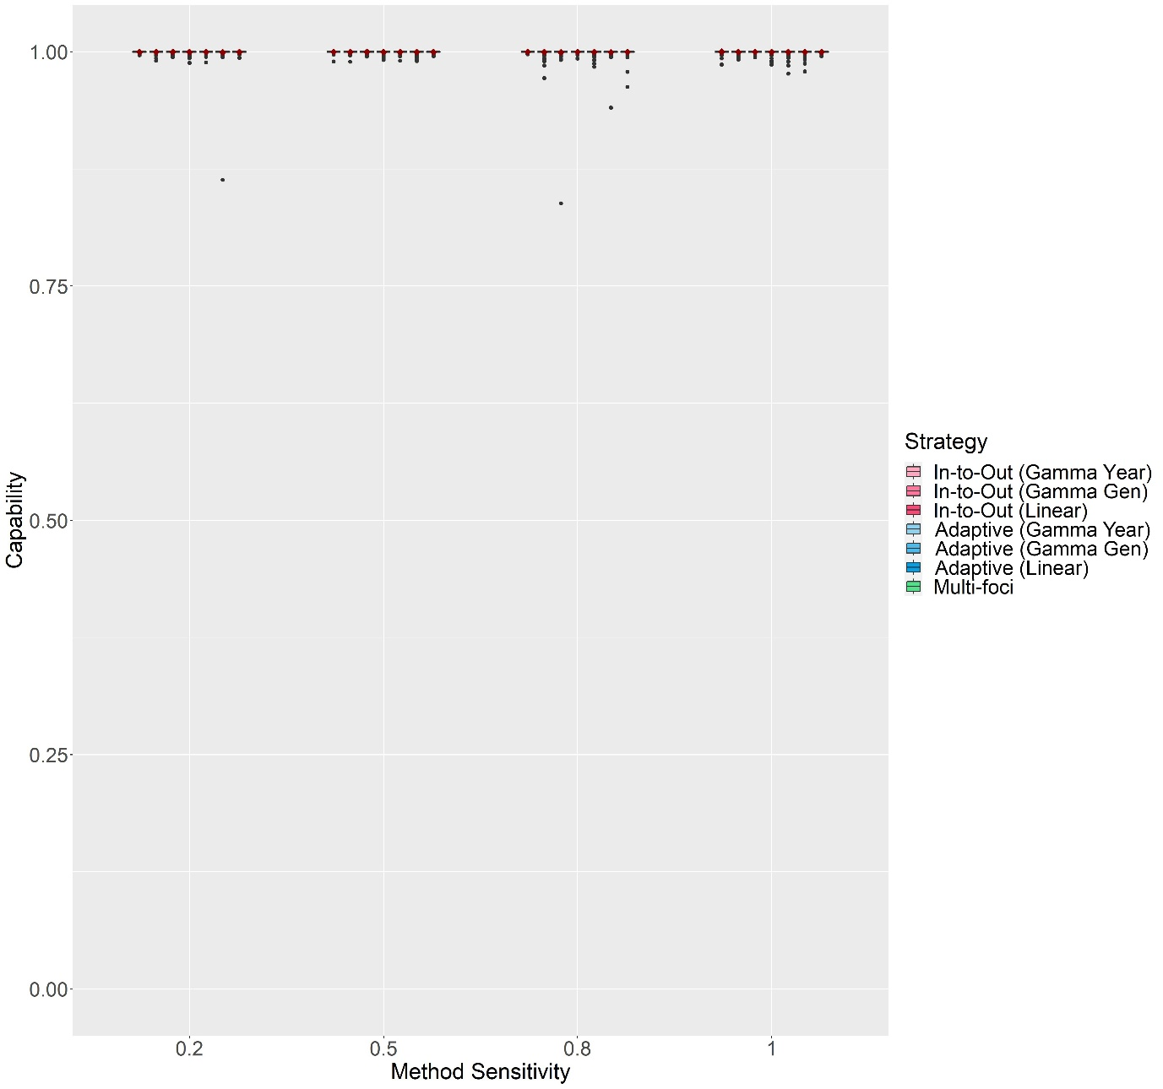

Figure S5: The change in Capability scores with Method Sensitivity of each delimiting strategy on a random host landscape in Scenario 1. The inspector-estimated spread distances matched the true values (550 m/generation and 750 m/year). For each realization, all delimiting strategies started from the origin of the epidemic, no asymptomatic period was included, and the inspector-estimated duration of the pest spread was matched with the true value (3 years). Boxplots were obtained from 500 iterations. Mean values are indicated with a dark red diamond.

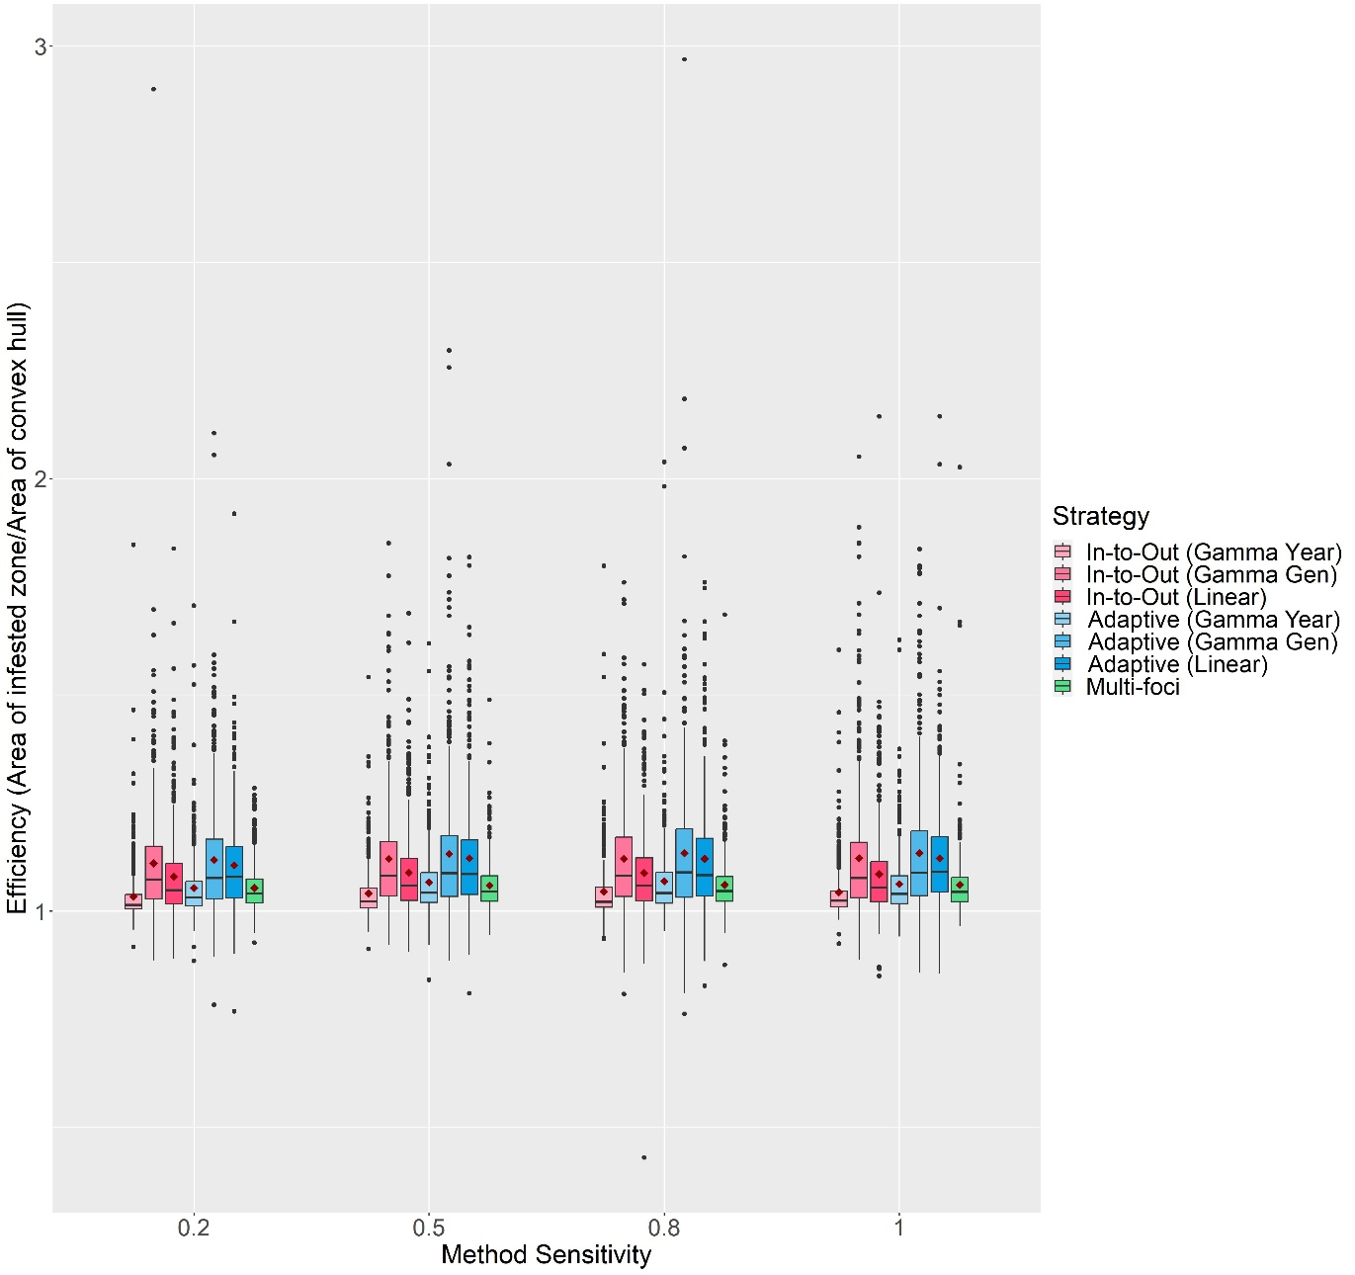

Figure S6: The change in Efficiency scores with Method Sensitivity of each delimiting strategy on a random host landscape in Scenario 1. The inspector-estimated spread distances matched the true values (550 m/generation and 750 m/year). For each realization, all delimiting strategies started from the origin of the epidemic, no asymptomatic period was included, and the inspector-estimated duration of the pest spread was matched with the true value (3 years). Boxplots were obtained from 500 iterations. Mean values are indicated with a dark red diamond.

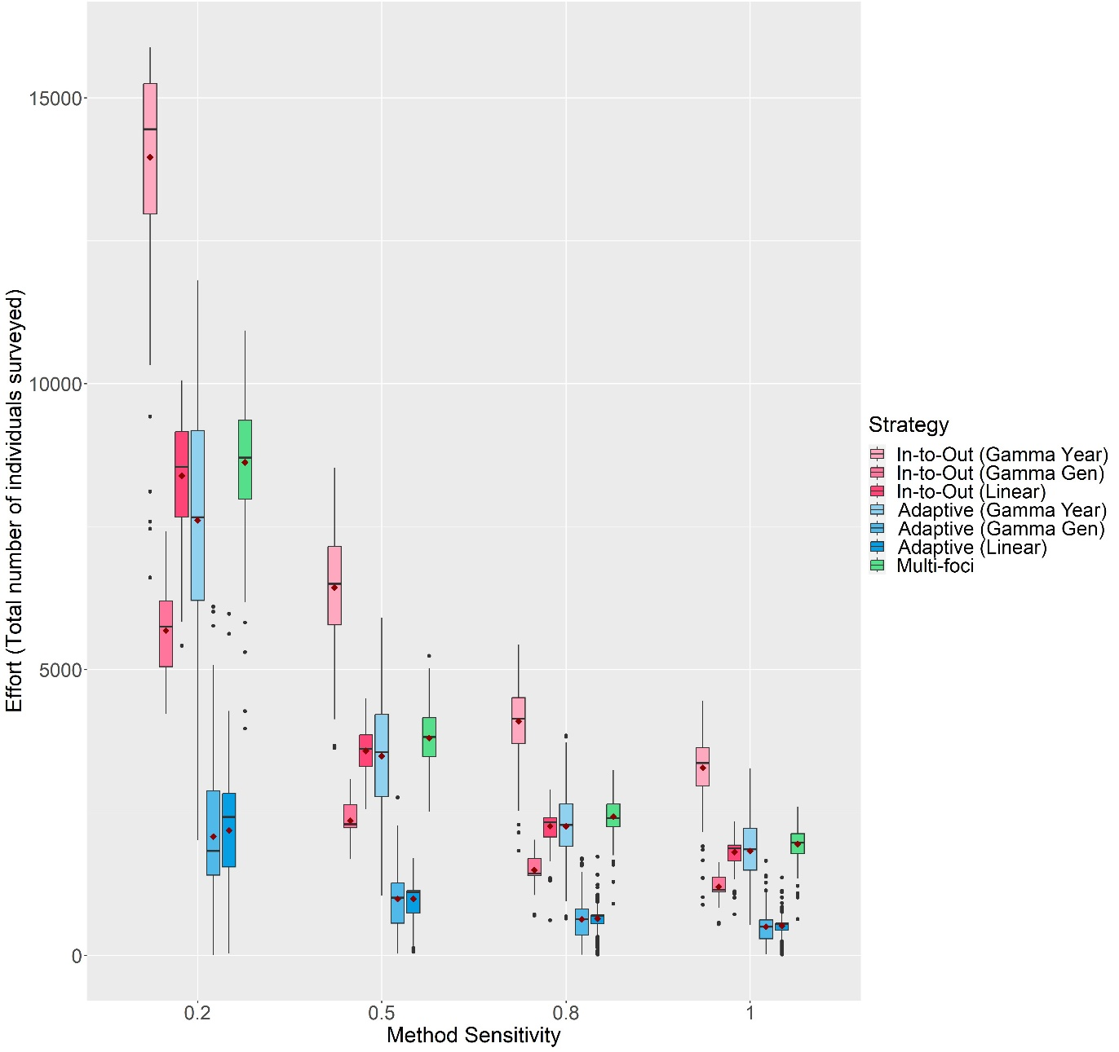

Figure S7: The change in Effort scores with Method Sensitivity of each delimiting strategy on a random host landscape in Scenario 1. The inspector-estimated spread distances matched the true values (550 m/generation and 750 m/year). For each realization, all delimiting strategies started from the origin of the epidemic, no asymptomatic period was included, and the inspector-estimated duration of the pest spread was matched with the true value (3 years). Boxplots were obtained from 500 iterations. Mean values are indicated with a dark red diamond.

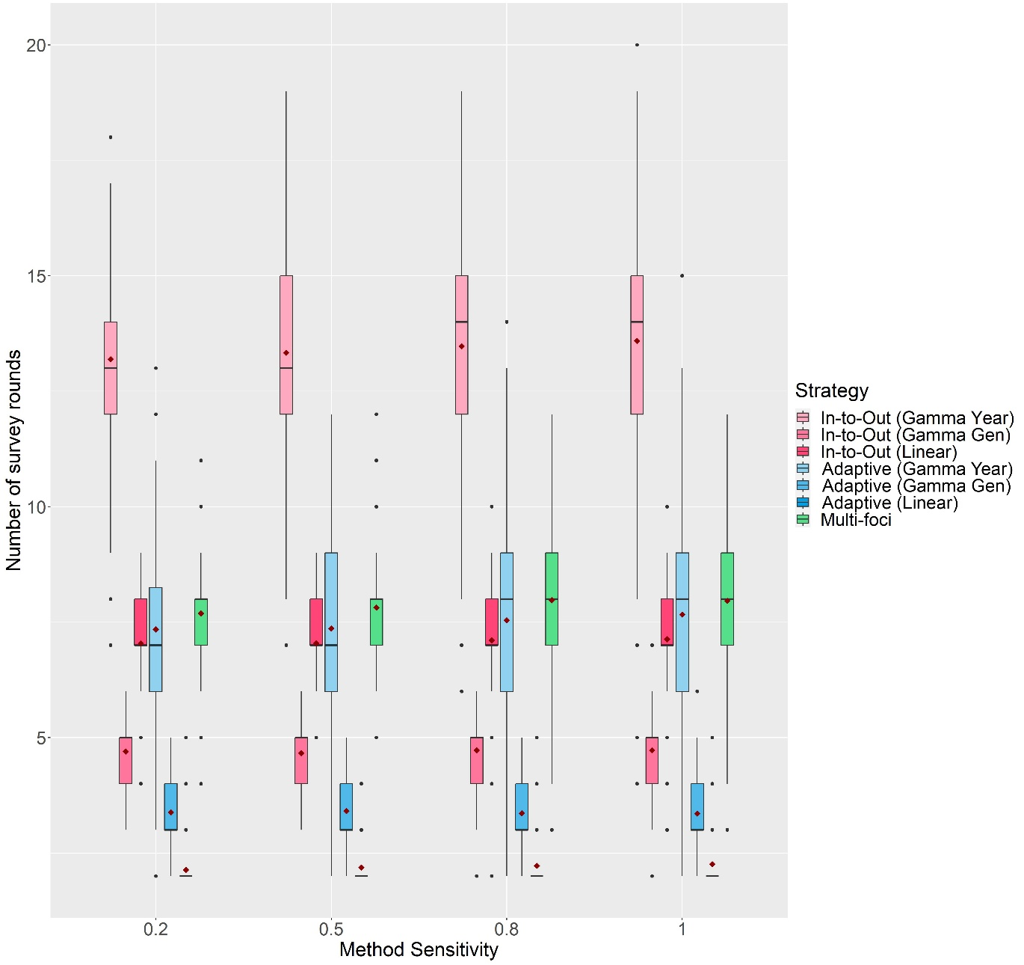

Figure S8: The change in the number of survey rounds each delimiting strategy took to delimit the potential infested zone on a random host landscape in Scenario 1 with Method Sensitivity. The inspector-estimated spread distances matched the true values (550 m/generation and 750 m/year). For each realization, all delimiting strategies started from the origin of the epidemic, no asymptomatic period was included, and the inspector-estimated duration of the pest spread was matched with the true value (3 years). Boxplots were obtained from 500 iterations. Mean values are indicated with a dark red diamond.

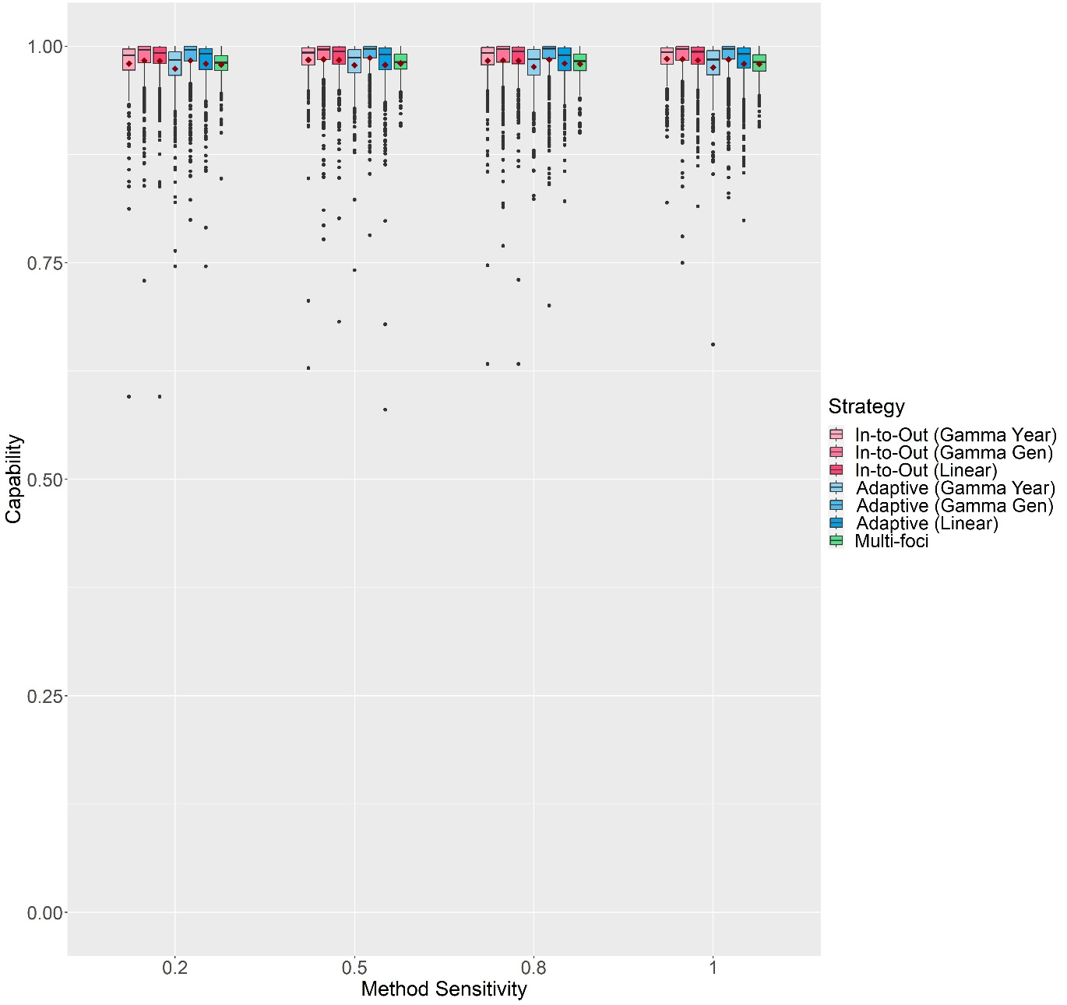

Figure S9: The change in Capability scores with Method Sensitivity of each delimiting strategy on a random host landscape in Scenario 2. The inspector-estimated spread distances matched the true values (550 m/generation and 750 m/year). For each realization, all delimiting strategies started from the origin of the epidemic, a 1-year asymptomatic period was included, and the inspector-estimated duration of the pest spread was matched with the true value (3 years). Boxplots were obtained from 500 iterations. Mean values are indicated with a dark red diamond.

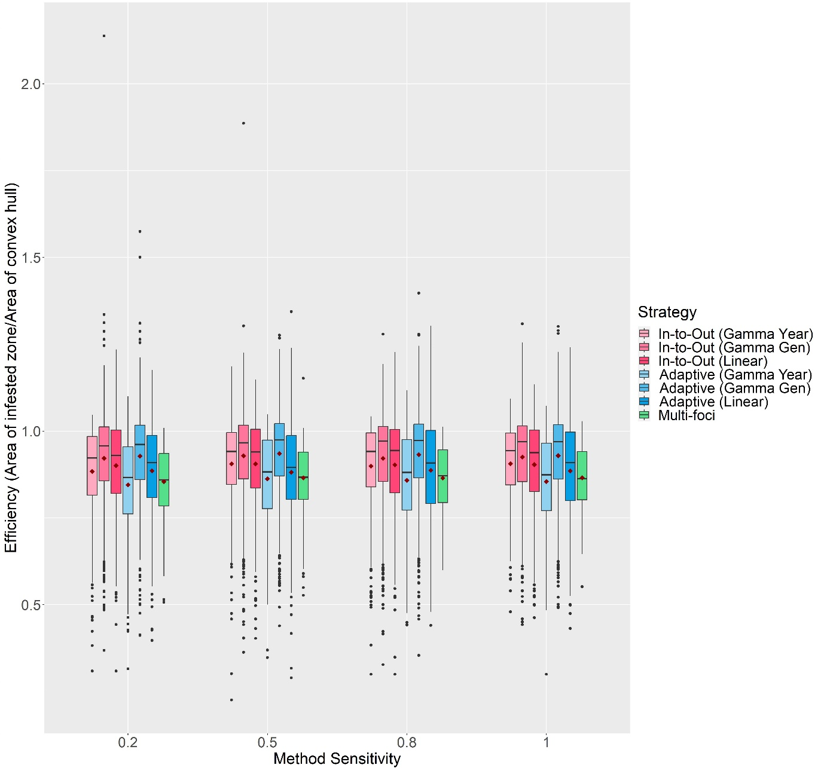

Figure S10: The change in Efficiency scores with Method Sensitivity of each delimiting strategy on a random host landscape in Scenario 2. The inspector-estimated spread distances matched the true values (550 m/generation and 750 m/year). For each realization, all delimiting strategies started from the origin of the epidemic, a 1-year asymptomatic period was included, and the inspector-estimated duration of the pest spread was matched with the true value (3 years). Boxplots were obtained from 500 iterations. Mean values are indicated with a dark red diamond.

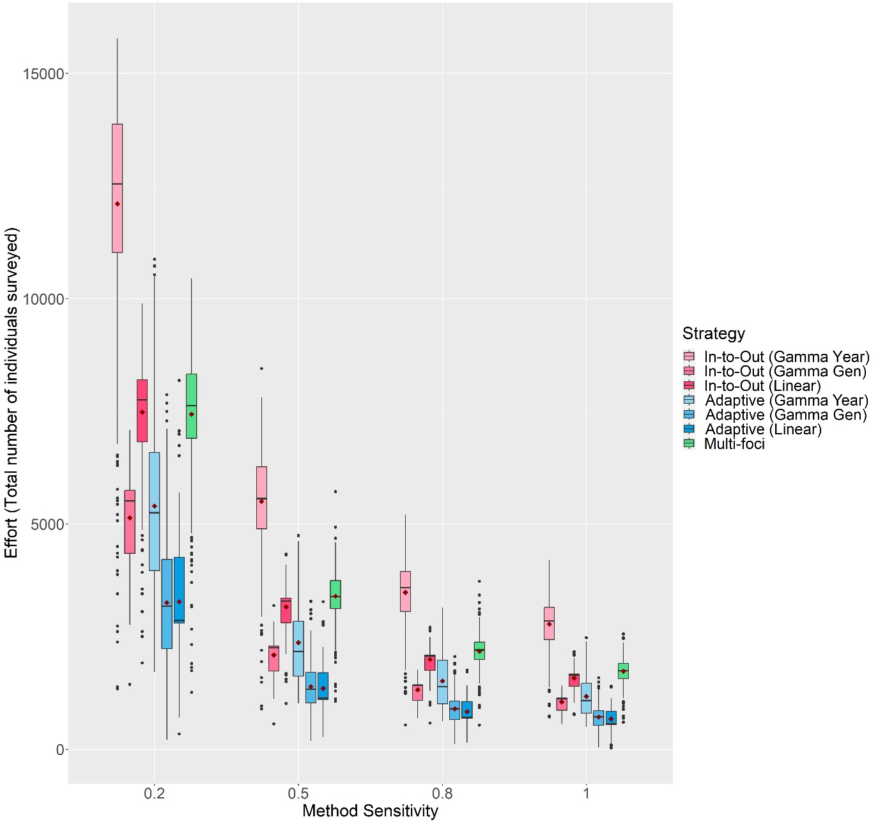

Figure S11: The change in Effort scores with Method Sensitivity of each delimiting strategy on a random host landscape in Scenario 2. The inspector-estimated spread distances matched the true values (550 m/generation and 750 m/year). For each realization, all delimiting strategies started from the origin of the epidemic, a 1-year asymptomatic period was included, and the inspector-estimated duration of the pest spread was matched with the true value (3 years). Boxplots were obtained from 500 iterations. Mean values are indicated with a dark red diamond.

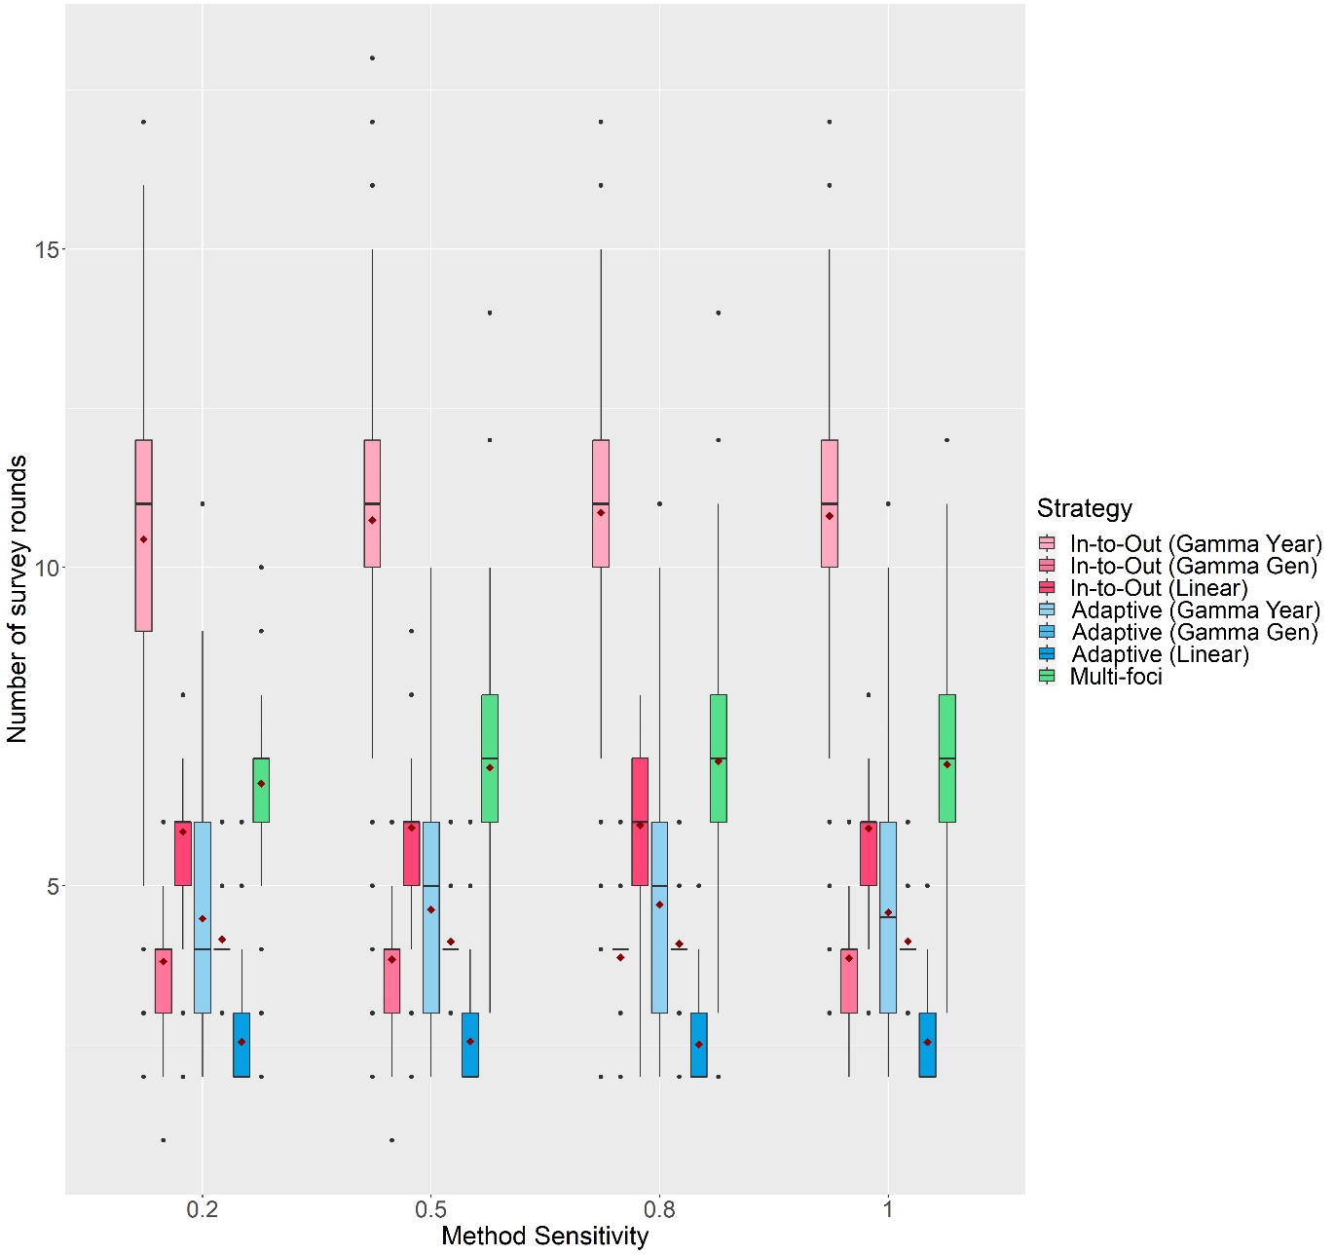

Figure S12: The change in the number of survey rounds each delimiting strategy took to delimit the potential infested zone on a random host landscape in Scenario 2 with Method Sensitivity. The inspector-estimated spread distances matched the true values (550 m/generation and 750 m/year). For each realization, all delimiting strategies started from the origin of the epidemic, a 1-year asymptomatic period was included, and the inspector-estimated duration of the pest spread was matched with the true value (3 years). Boxplots were obtained from 500 iterations. Mean values are indicated with a dark red diamond.

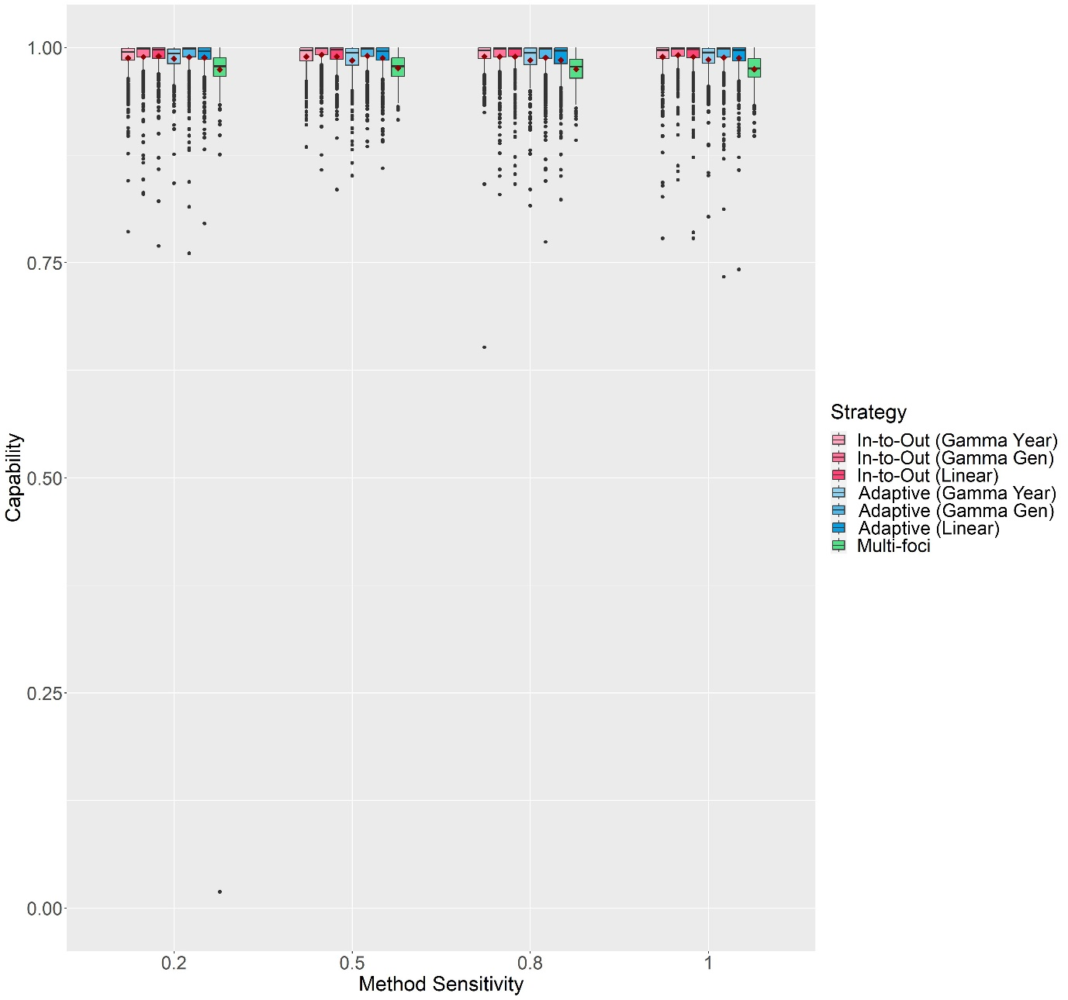

Figure S13: The change in Capability scores with Method Sensitivity of each delimiting strategy on a random host landscape in Scenario 3. The inspector-estimated spread distances matched the true values (550 m/generation and 750 m/year). For each realization, all delimiting strategies started from the same randomly selected symptomatic individual, a 1-year asymptomatic period was included, and the inspector-estimated duration of the pest spread was matched with the true value (3 years). Boxplots were obtained from 500 iterations. Mean values are indicated with a dark red diamond.

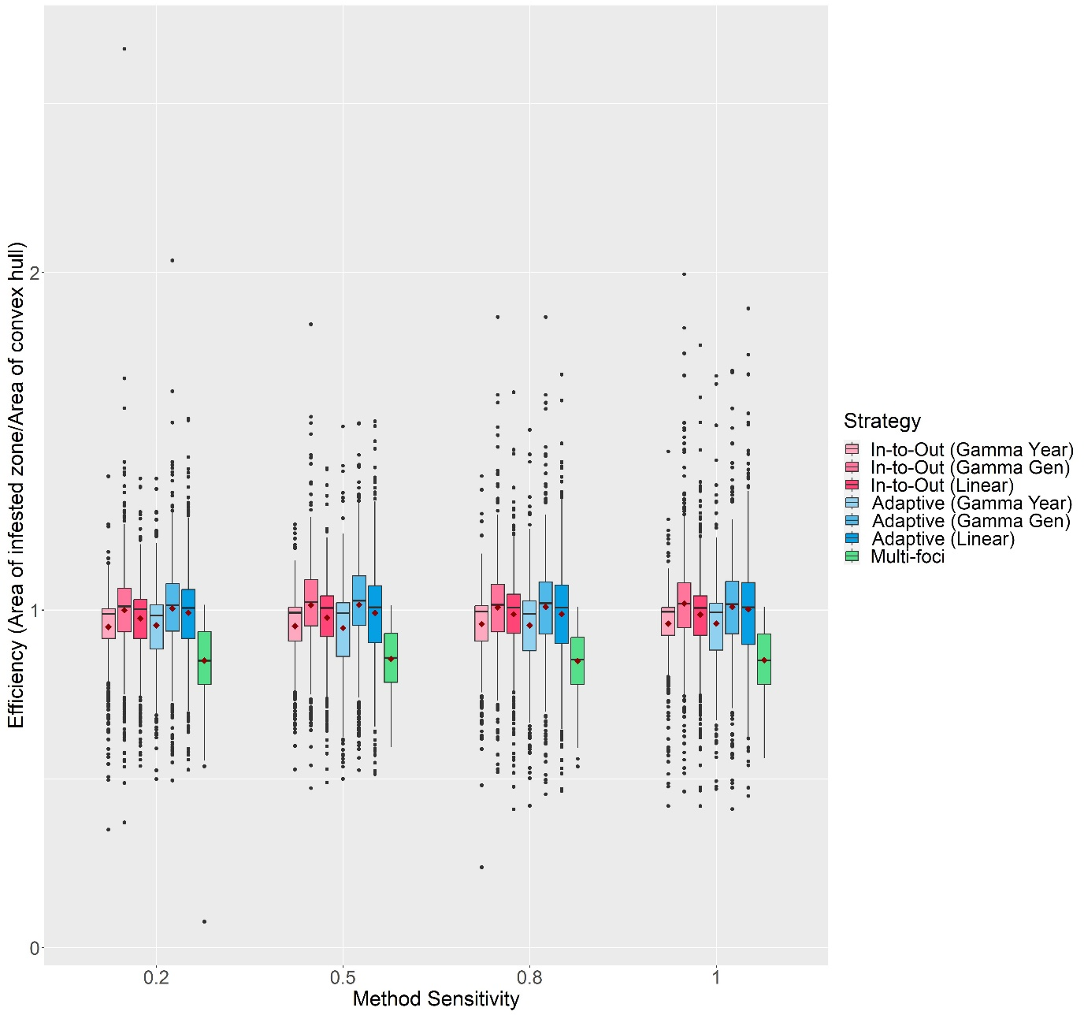

Figure S14: The change in Efficiency scores with Method Sensitivity of each delimiting strategy on a random host landscape in Scenario 3. The inspector-estimated spread distances matched the true values (550 m/generation and 750 m/year). For each realization, all delimiting strategies started from the same randomly selected symptomatic individual, a 1-year asymptomatic period was included, and the inspector-estimated duration of the pest spread was matched with the true value (3 years). Boxplots were obtained from 500 iterations. Mean values are indicated with a dark red diamond.

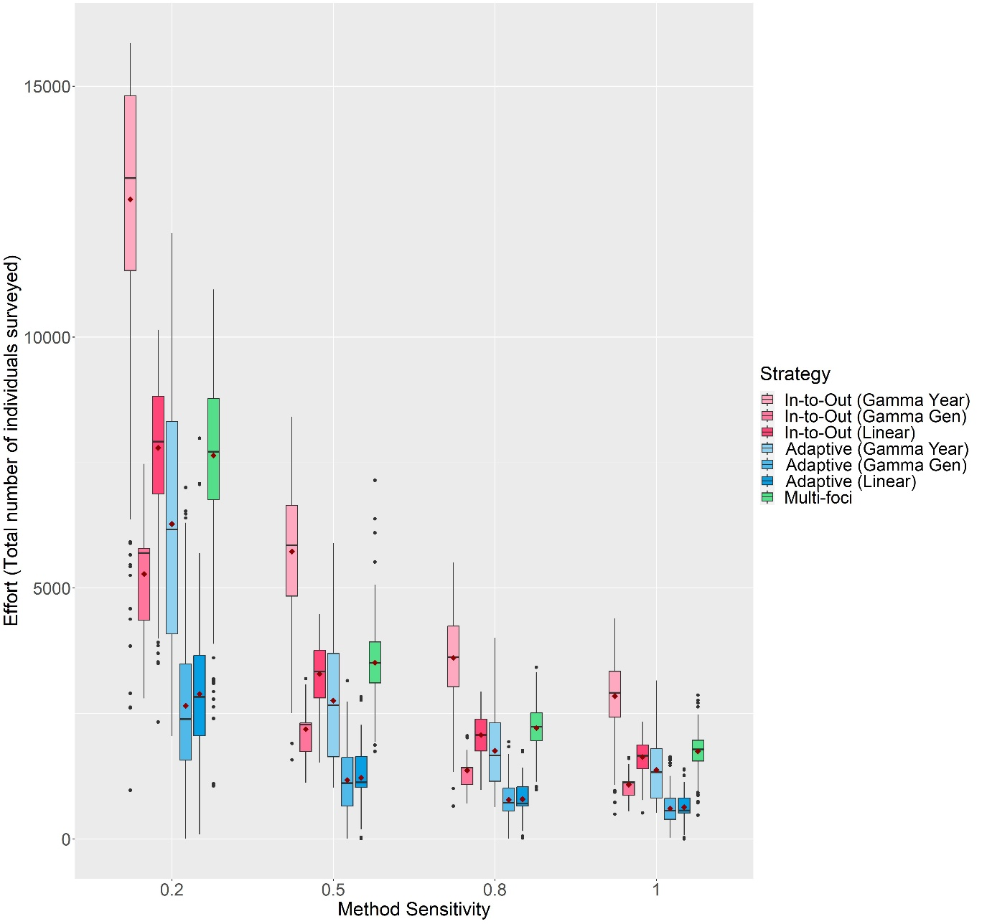

Figure S15: The change in Effort scores with Method Sensitivity of each delimiting strategy on a random host landscape in Scenario 3. The inspector-estimated spread distances matched the true values (550 m/generation and 750 m/year). For each realization, all delimiting strategies started from the same randomly selected symptomatic individual, a 1-year asymptomatic period was included, and the inspector-estimated duration of the pest spread was matched with the true value (3 years). Boxplots were obtained from 500 iterations. Mean values are indicated with a dark red diamond.

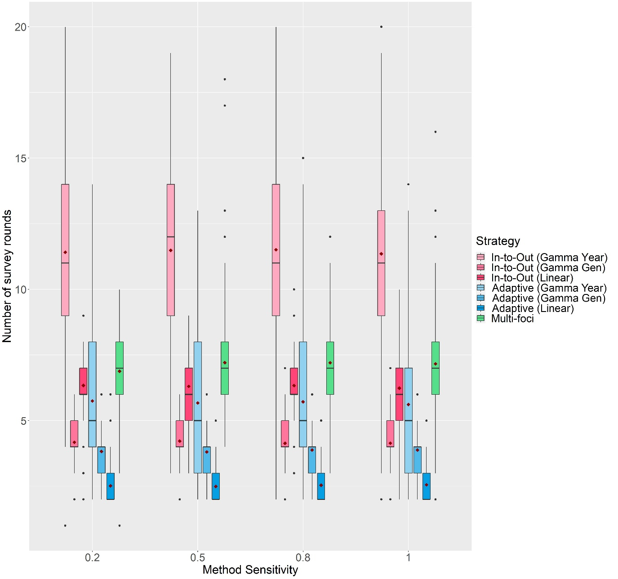

Figure S16: The change in the number of survey rounds each delimiting strategy took to delimit the potential infested zone on a random host landscape in Scenario 3 with Method Sensitivity. The inspector-estimated spread distances matched the true values (550 m/generation and 750 m/year). For each realization, all delimiting strategies started from the same randomly selected symptomatic individual, a 1-year asymptomatic period was included, and the inspector-estimated duration of the pest spread was matched with the true value (3 years). Boxplots were obtained from 500 iterations. Mean values are indicated with a dark red diamond.

**\*\*Figures S17 to S29 are large and difficult to view in this Word document. Hence, they have been uploaded as individual high-resolution images. Their captions are as follows:**

Figure S17: The change in Capability scores of all seven delimiting strategies on a random host landscape in Scenario 4 with Method Sensitivity, inspector-estimated spread distances and duration of pest spread. For each realization, all delimiting strategies started from the same randomly selected symptomatic individual, and a 1-year asymptomatic period was included. Boxplots were obtained from 500 iterations. Mean values are indicated with a dark red diamond.

Figure S18: The change in Efficiency scores of all seven delimiting strategies on a random host landscape in Scenario 4 with Method Sensitivity, inspector-estimated spread distances and duration of pest spread. For each realization, all delimiting strategies started from the same randomly selected symptomatic individual, and a 1-year asymptomatic period was included. Boxplots were obtained from 500 iterations. Mean values are indicated with a dark red diamond.

Figure S19: The change in Effort scores of all seven delimiting strategies on a random host landscape in Scenario 4 with Method Sensitivity, inspector-estimated spread distances and duration of pest spread. For each realization, all delimiting strategies started from the same randomly selected symptomatic individual, and a 1-year asymptomatic period was included. Boxplots were obtained from 500 iterations. Mean values are indicated with a dark red diamond.

Figure S20: The change in the number of survey rounds each delimiting strategy took to delimit the potential infested zone on a random host landscape in Scenario 4 with Method Sensitivity, inspector-estimated spread distances and duration of pest spread. For each realization, all delimiting strategies start from the same randomly selected symptomatic individual, and a 1-year asymptomatic period was included. Boxplots were obtained from 500 iterations. Mean values are indicated with a dark red diamond.

Figure S21: The change in Capability scores of the In-to-Out (Gamma Gen) and Adaptive (Gamma Gen) strategies on a random host landscape in Scenario 5 with the inspector-estimated spread distances, mean number of generations per year and duration of pest spread. For each realization, both delimiting strategies started from the same randomly selected symptomatic individual, and a 1-year asymptomatic period was included. Method sensitivity was kept constant at 0.5. Boxplots were obtained from 500 iterations. Mean values are indicated with a dark red diamond.

Figure S22: The change in Efficiency scores of the In-to-Out (Gamma Gen) and Adaptive (Gamma Gen) strategies on a random host landscape in Scenario 5 with the inspector-estimated spread distances, mean number of generations per year, and duration of pest spread. For each realization, both delimiting strategies started from the same randomly selected symptomatic individual, and a 1-year asymptomatic period was included. Method sensitivity was kept constant at 0.5. Boxplots were obtained from 500 iterations. Mean values are indicated with a dark red diamond.

Figure S23: The change in Effort scores of the In-to-Out (Gamma Gen) and Adaptive (Gamma Gen) strategies on a random host landscape in Scenario 5 with the inspector-estimated spread distances, mean number of generations per year, and duration of pest spread. For each realization, both delimiting strategies started from the same randomly selected symptomatic individual, and a 1-year asymptomatic period was included. Method sensitivity was kept constant at 0.5. Boxplots were obtained from 500 iterations. Mean values are indicated with a dark red diamond.

Figure S24: The change in the number of survey rounds the In-to-Out (Gamma Gen) and Adaptive (Gamma Gen) strategies took to delimit the potential infested zone on a random host landscape in Scenario 5 with the inspector-estimated spread distances, mean number of generations per year, and duration of pest spread. For each realization, both delimiting strategies started from the same randomly selected symptomatic individual, and a 1-year asymptomatic period was included. Method sensitivity was kept constant at 0.5. Boxplots were obtained from 500 iterations. Mean values are indicated with a dark red diamond.

Figure S25: Change in the Capability scores of the delimiting strategies on various host landscape types with the inspector-estimated spread distances and duration of pest spread. For each realization, all delimiting strategies started from the same randomly selected symptomatic individual, and a 1-year asymptomatic period was included. Method sensitivity was kept constant at 0.5. Boxplots were obtained from 500 iterations except for the Extreme Clustered Host Distribution columns where boxplots were obtained from 150 iterations. Mean values are indicated with a dark red diamond.

Figure S26: The change in Efficiency scores of the delimiting strategies on various host landscape types with inspector-estimated spread distances and duration of pest spread. For each realization, all delimiting strategies started from the same randomly selected symptomatic individual, and a 1-year asymptomatic period was included. Method sensitivity was kept constant at 0.5. Boxplots were obtained from 500 iterations except for the Extreme Clustered Host Distribution columns where boxplots were obtained from 150 iterations. Mean values are indicated with a dark red diamond.

Figure S27: The change in Effort scores of the delimiting strategies on various host landscape types with the inspector-estimated spread distances and duration of pest spread. For each realization, all delimiting strategies started from the same randomly selected symptomatic individual, and a 1-year asymptomatic period was included. Method sensitivity was kept constant at 0.5. Boxplots were obtained from 500 iterations except for the Extreme Clustered Host Distribution columns where boxplots were obtained from 150 iterations. Mean values are indicated with a dark red diamond.

Figure S28: The change in the number of survey rounds each of the delimiting strategies took to delimit the potential infested zone on various host landscape types with the inspector-estimated spread distances and duration of pest spread. For each realization, all delimiting strategies started from the same randomly selected symptomatic individual, and a 1-year asymptomatic period was included. Method sensitivity was kept constant at 0.5. Boxplots were obtained from 500 iterations except for the Extreme Clustered Host Distribution columns where boxplots were obtained from 150 iterations.

Figure S29: Change in the proportion of times perfect Capability was achieved by each of the delimiting strategies on various host landscape types with the inspector-estimated spread distances and duration of pest spread. For each realization, all delimiting strategies started from the same randomly selected symptomatic individual, and a 1-year asymptomatic period was included. Method Sensitivity was kept constant at 0.5. Each bar was obtained from 500 iterations.

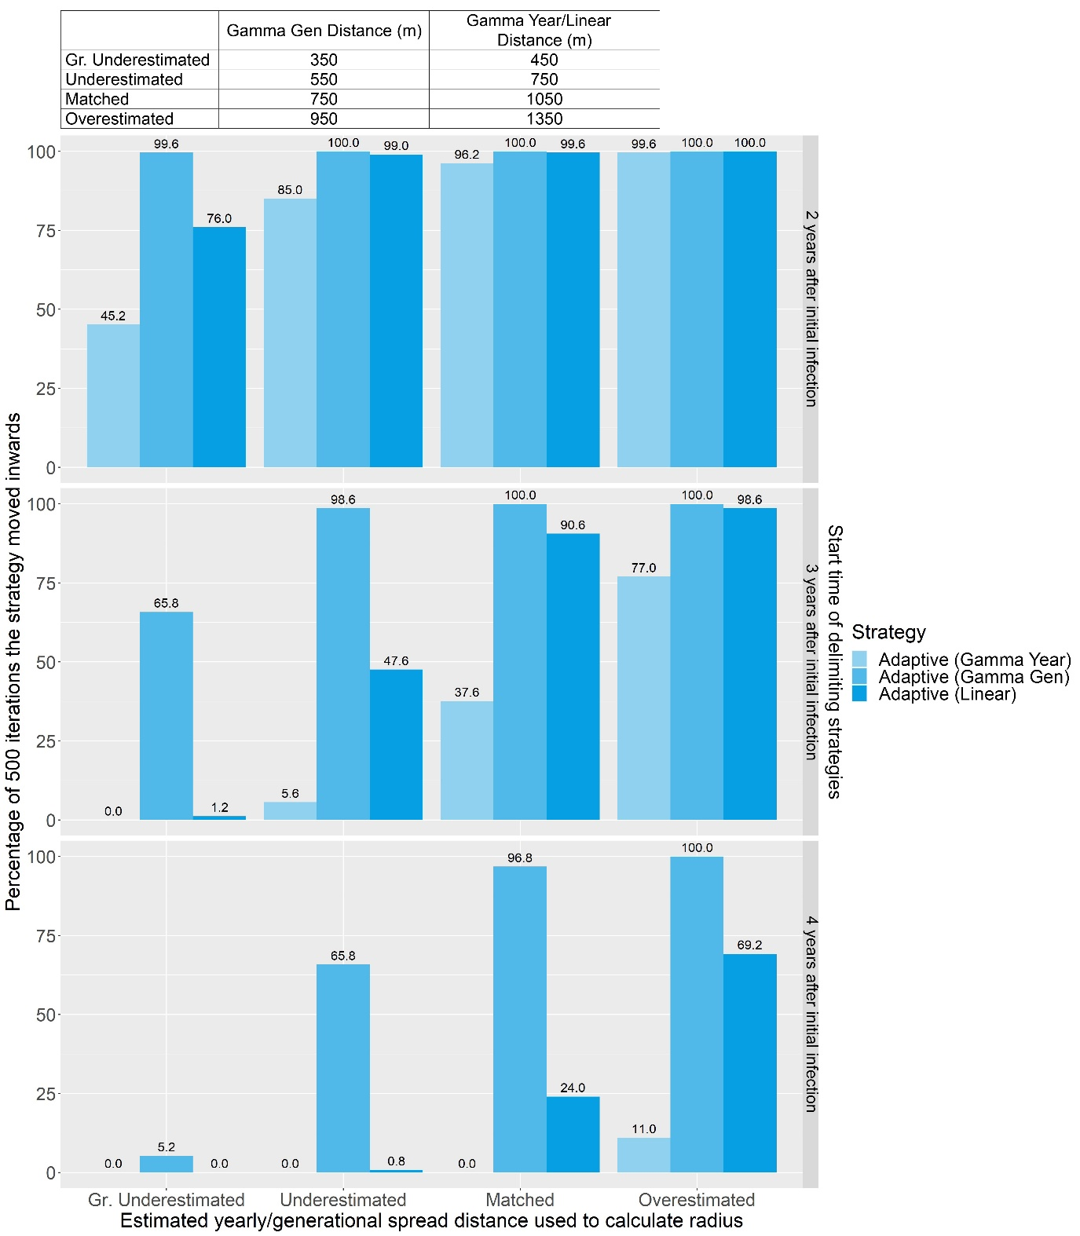

Figure S30: Bar graph showing how frequently each version of the Adaptive strategy correctly estimated the distance of epidemic spread and moved inwards on a random host landscape and when Method Sensitivity = 0.5.

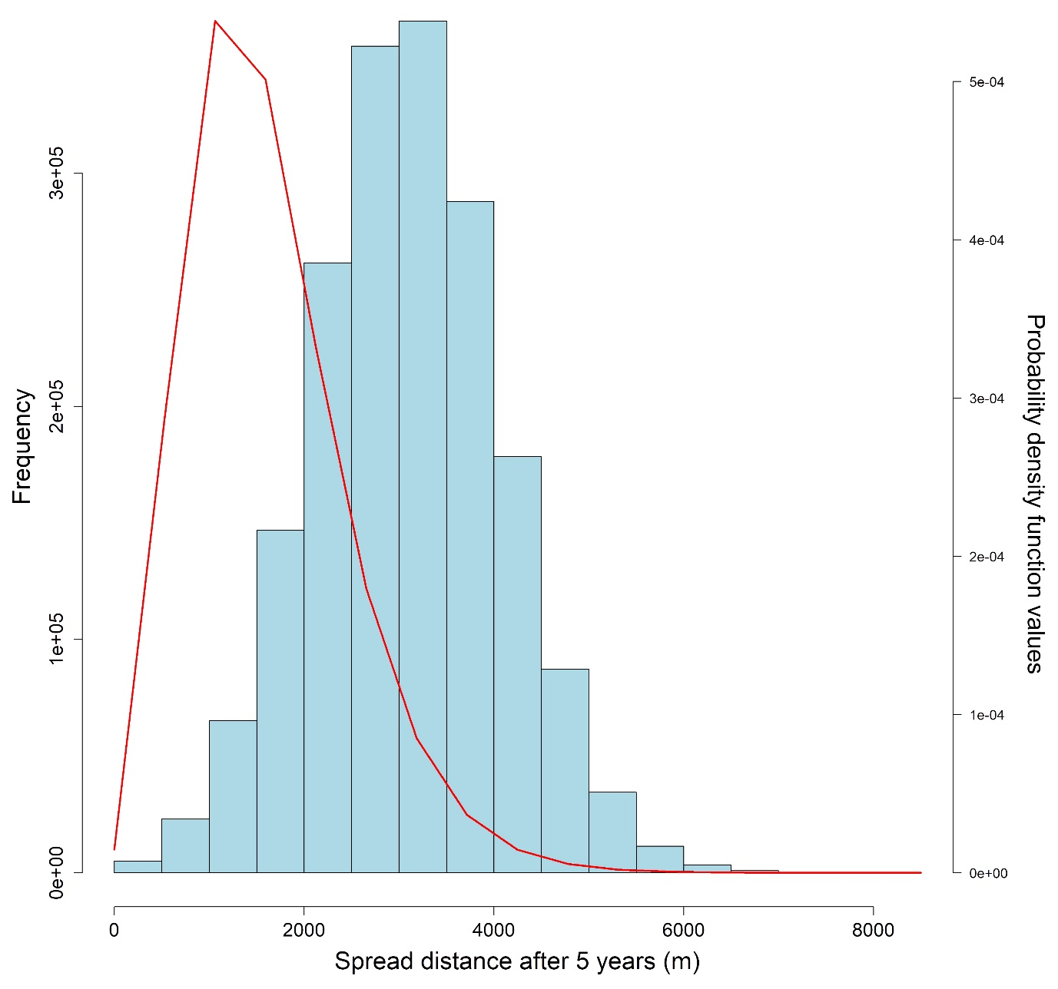

Figure S31: Histogram of the spread distances after five years and the probability density function values of a gamma distribution with a shape parameter value of 5 and a rate parameter value calculated with $-\frac{\ln{(1-0.95)}}{1056.911}$.

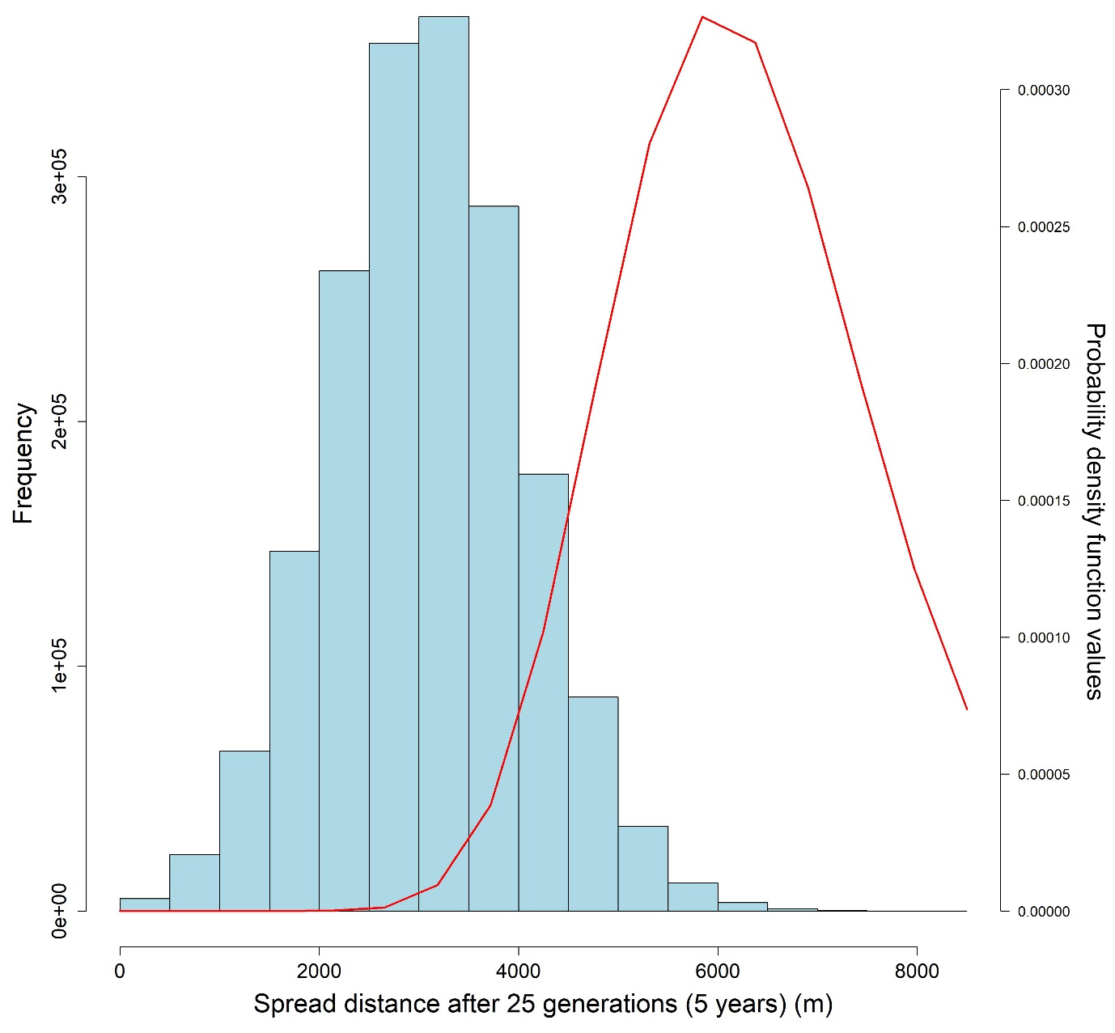

Figure S32: Histogram of the spread distances after twenty-five generations (five years) and the probability density function values of a gamma distribution with a shape parameter value of 25 and a rate parameter value calculated with $-\frac{\ln{(1-0.95)}}{737.69}$.

## Animated Figures



Figure SA1: Animated GIF showing the spread of the simulated pest in a random host landscape. Black circles indicate susceptible individuals, pink dots represent symptomatic individuals, blue dots represent asymptomatic individuals, and the red dot represents the first infected individual or the origin of the epidemic.



Figure SA2: Animated GIF showing how the In-to-Out strategy works. Colored dots represent detections of infected individuals, while the corresponding-colored bands represent the surveys conducted following these detections. The final purple circle represents the boundary of the delimited potential infested zone.



Figure SA3: Animated GIF showing how the Adaptive strategy works when a detection is made in the preliminary survey. Colored dots represent detections of infected individuals, while the corresponding-colored bands represent the surveys conducted following these detections. The final purple circle represents the boundary of the delimited potential infested zone.



Figure SA4: Animated GIF showing how the Adaptive strategy works when no detection is made in the preliminary survey. Colored dots represent detections of infected individuals, while the corresponding-colored bands represent the surveys conducted following these detections. The final purple circle represents the boundary of the delimited potential infested zone.



Figure SA5: Animated GIF showing how the Multi-foci strategy works. Colored dots represent detections of infected individuals, while the corresponding-colored bands represent the surveys conducted following these detections. The final purple circle represents the boundary of the delimited potential infested zone.



Figure SA6: Animated GIF showing a realization of the Adaptive (Gamma Gen) strategy on an Extreme Clustered Poisson Cluster Process host landscape. The purple dot represents the initial detection, pink circles represent symptomatic individuals, blue circles represent asymptomatic individuals, black circles represent susceptible individuals, and the green dot represents the subsequent detection. Large colored circles represent the boundaries of the survey bands. The blue dotted circle represents the outer boundary of the preliminary survey.



Figure SA7: Animated GIF showing a realization of the Adaptive (Gamma Year) strategy on the same Extreme Clustered Poisson Cluster Process host landscape as Fig. SA6. The purple dot represents the initial detection, pink circles represent symptomatic individuals, blue circles represent asymptomatic individuals, black circles represent susceptible individuals, and the green dot represents the subsequent detection. Large colored circles represent the boundaries of the survey bands. The blue dotted circle represents the outer boundary of the preliminary survey.